Cross Border Payments Platform

Functional Requirements Document

# **Points of Contact**

|  |  |
| --- | --- |
| Name | Role |
| Seerat Arora | Project Manager |
| Rajeshwar Tripathi | Development Lead |
| Lakshmi Bandhu Daw | QA Lead |

**Table of Contents**

**Points of Contact** 1

**1.** **Overview** 3

**2.** **Purpose of the document** 3

**3.** **In scope requirements** 3

**4.** **Out of Scope requirements** 3

**5.** **Actors in the application** 3

**6.** **Flow Diagram** 4

**7.** **Web Application** 5

**7.1.** **Registration** 5

**7.2.** **KYC** 12

**7.3.** **Login** 13

**7.4.** **User Management** 13

**7.5.** **Transaction processing** 14

**7.6.** **Transaction statuses** 18

**7.7.** **Audit Trail** 18

**7.8.** **Pre-Loaded cards** 18

**7.9.** **Multi Geography Support** 18

**7.10.** **Reports** 19

**7.11.** **FX details** 19

**7.12.** **Multi Language Support** 20

**7.13.** **Customer Profile** 20

**7.14.** **Financial institution Profile** 20

**7.15.** **Service Provider** 21

**7.16.** **Pairing Management** 21

**7.17.** **Member Management** 21

**7.18.** **Account Summary** 22

**7.19.** **Party Services** 22

**7.20.** **Beneficiary Addition** 23

**7.21.** **Save Cards** 23

**7.22.** **Dashboard** 23

**8.** **Customer Journeys** 24

**9.** **Non-Functional Requirements** 25

**10.** **Security** 26

**11.** **Third-Party Backend Integration** 26

# **Overview**

The payment application aims at achieving cross border transactions seamlessly. The platform forms a hub to connect the various financial institutions and their customers to disbursing partners and FX providers and find a cross border transfer method other than SWIFT to enable low-cost transactions.

# **Purpose of the document**

This document aims at capturing all the requirements needed to build the payment application.

# **In scope requirements**

* Registration
* User management
* Transaction processing
* Dashboard
* Audit trail
* Reporting
* Mobile application
* Card payments
* Alternate payments
* Ticketing system through Dialogview
* Blockchain

# **Out of Scope requirements**

* Fiat and Crypto Wallet

# **Actors in the application**

The cross-border payment application must have a different and diverse set of actors who can use this application for their specific use cases. The required actors are –

|  |  |  |  |
| --- | --- | --- | --- |
| **Actor Type** | **Actor** | **Description** | **Roles** |
| Company | Millennium | Enterprise application provider (Payment application provider) | * Enterprise Admin * Enterprise Compliance officer (ECO) * Enterprise Payments Operator (EPO) * Enterprise Support Officer (L1) * Enterprise Support Manager (L2) * Tech support (L3) |
| Financial Institution | Bank/MSB (Money Service business) | The payment initiators who will be connected to our application to start the payment process. | * Teller * Compliance officer * Approver * Authoriser |
| Financial Institution | FX Provider | Banks/Institutions that will be providing the daily FX rates. These institutions will hold the trading account for the MSB/Initiating bank to facilitate the disbursement. | API integration with the institution. No user access |
| Financial Institution | Card Acquiring services | Acquirer banks to ensure domestic debit card processing. | API integration with the institution. No user access |
| Financial Institution | Payment Service Providers | Service providers that integrate payment gateways and acquirer banks to enable alternate payments. Alternate payments like IMPS, NEFT, RTGS, ACH etc needs to be supported through these institutions. | API integration with the institution. No user access |
| Agent | * Affiliate | Agent is an affiliate who will act on behalf of the financial institution | Teller access external to financial institution |
| Individual | * Mobile app user / Web user | These are end customers who initiate payment through the registered financial institutions. | The individual users need to have access to the platform to initiate transaction. The access should be similar to the Teller user. |
| Disbursing Partner | Disbursing banks/ Agents/ Payee/ Remittance partner | The banks or institutions that perform the disbursing of the transaction to the end user. They also provide alternate payment methods. | The following user access needs to be given to this actor –   * Disbursing agent |

# **Flow Diagram**

When FX provider and Remittance partner are different institutions

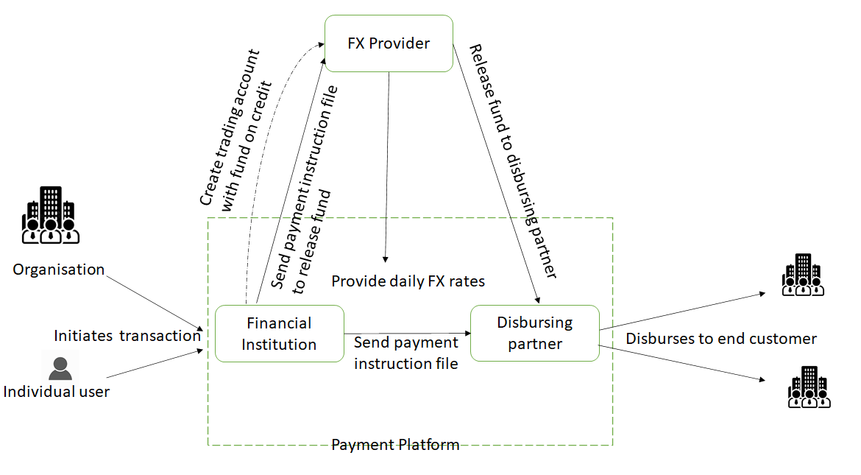

# **Web Application**

# **Registration**

Any actor trying to use the web platform needs to register for the service the first time they access the platform. Registration is a multi-step process where the user enters details about their company/personal details and then need to login to the portal after setting the password.

Initially the user will be provided with a signup form to begin the registration process. The form would contain the following fields –

|  |  |  |
| --- | --- | --- |
| Field Name | Field Type | Description |
| First Name | Alpha Numeric | Name of the person who needs to be created as admin |
| Last Name | Alpha Numeric |  |
| Email id | Alpha numeric | Email id of the admin. This id will be used for all communication to admin and for login purpose |
| Phone number | Numeric | Phone number of the admin user |
| Company Name | Alpha Numeric | Name of the company trying to register to the application |
| Password | Alpha numeric | Password should be 8 to 15 characters!  Password must contain only characters, numeric digits, underscore and first character must be a letter |
| Confirm Password | Alpha numeric | Repeat the password |

Once the sign-up form is submitted, the user is re-directed to the login page to login to the application. The user is created as an admin for the registering organisation. Now the user needs to fill up the remaining registration form to complete the onboarding.

For financial institutions the process needs to be followed as defined above. For organisations, an invite is sent out from the financial institutions to the organisation to register. On clicking the link, they need to be sent to the sign-up form from where the process would be the same. This would ensure that the organisation/agent is registered under the inviting financial institution.

Option 1 – Financial Institution (Initiator/ Remittance partner)

The registration form needs to collect the following details from the user

Member Type:

The application needs to collect the data whether the registering financial institution is a payment initiator or a payment remitter or both.

|  |  |  |
| --- | --- | --- |
| Field Name | Field Type | Description |
| Member Type | Multi select Drop down | Pre-populated with the following values –   * Payment Initiator * Payment Remitter * Both |

All the below details need to be collected from the registering person through the registration form.

**Note: All the below details need to be included in the same registration form.**

Company Data:

|  |  |  |
| --- | --- | --- |
| Field Name | Field Type | Description |
| Company Name | Alpha Numeric | Name of the company registering |
| Company Registration number | Alpha numeric | The registration ID for the company as per that particular country norms |
| Company Business Purpose | Text | The area of business that the company is currently doing |
| Date of Establishment | Date picker | Date when the company was established |
| Company Website | Alpha numeric | The website of the company registering. |
| Company Address | Text and numeric | Street/ house/ Flat no  State/Province  Zip/Postal code  City  Country |
| Correspondence Address (if Different) | Text and numeric | Street/ house/ Flat no  State/Province  Zip/Postal code  City  Country |

Identity Details – Identity details and documents to be provided in this section.

|  |  |  |
| --- | --- | --- |
| Field Name | Field Type | Description |
| Identity Type | List of Identity documents | List of Identity documents will be provided, out of which one can be selected for further verification. |
| Identity Number | Numeric |  |
| Issue Date | Date Picker | Date of issue of the ID card |
| Expiry Date | Date Picker | Date of expiry of the ID card |
| Issuing State | Text | Name of the state that issued the ID proof |
| Issuing country | Text | Name of the country that issued the ID proof |
| Issuing Description | Text | Brief about the issuing |
| Upload document | File upload and Drag and Drop option | Provision for the company to upload KYC documents, Network Participation Agreement, and pairing agreement to be saved into repository for future use. |

Primary Contact details – This section needs to be repeated multiple times depending on the number of owners are there for that company. This whole widget can be repeated any number of times based on the number of countries to be added.

|  |  |  |
| --- | --- | --- |
| Field Name | Field Type | Description |
| First Name | Alpha Numeric | Name of the primary contact person in the company |
| Middle Name | Alpha numeric |  |
| Last Name | Alpha numeric |  |
| Date of Birth | Date Picker | Date of birth of the contact person |
| Phone Number | Numeric | Contact number of the person |
| SSN |  |  |
| Ownership | Alpha numeric | Percentage of ownership for each contact person |
| Residential Address | Text and Numeric | Street/ house/ Flat no  State/Province  Zip/Postal code  City  Country |
| Identity Details | Text and Numeric | Identity Type/ Identity Number/ Issue Date/ Expiry Date/ Issuing State/ Issuing country/ Issuing Description |
| Upload Identity Document | File upload and Drag and Drop option | Provision for the company to upload KYC documents, Network Participation Agreement, and pairing agreement to be saved into repository for future use. |

If the Registration Type was chosen as Payment Disburser, then this section needs to be displayed.

Admin Details – This section is to provide details of the admin of the company.

|  |  |  |
| --- | --- | --- |
| Field Name | Field Type | Description |
| First Name | Alpha Numeric | Name of the primary contact person in the company |
| Middle Name | Alpha numeric |  |
| Last Name | Alpha numeric |  |
| Email | Alpha numeric | Email address of the admin user |

* Once the registration form is submitted, the registration must come to the ECO for approval.
* The ECO performs a KYC on the financial institution and based on the result approves or rejects the registration.
* Once registered, the financial institution is sent to the EPO queue. The EPO ensures the integration completion and certification for the registered financial institution.
* The EPO also edits the financial institution profile to include pairing details like paired disbursing partner, paired country and paired currency, FX partner, Compliance partner and all such other details. This is done based on the pairing agreement uploaded. SLA is provided by the remittance partner as part of the pairing agreement.
* If a KYB is rejected/ approved an email needs to be sent out to the primary contact of that company informing of the same and the reason for rejection if rejected.
* The user can start using the application (create users, upload transaction etc ) only once the KYB/KYC is approved.

Password setting page –

|  |  |  |
| --- | --- | --- |
| Field Name | Field Type | Description |
| Password | Alpha Numeric | User can key in the password for their login |
| Re-enter Password | Alpha Numeric | Enter password again |
| Set Password | Button | On Click of this button the password is set. |

Option 2 – Organisation

An organisation will receive an invite through mail from the associated financial institution with a link to the registration form. The organisation that enters details through the registration link is mapped as a customer under the financial institution. The following details will be collected from the organisation through the registration form.

Company Data:

|  |  |  |
| --- | --- | --- |
| Field Name | Field Type | Description |
| Company Name | Alpha Numeric | Name of the company registering |
| Company Registration number | Alpha numeric | The registration ID for the company as per that particular country norms |
| Company Business Purpose | Text | The area of business that the company is currently doing |
| Date of Establishment | Date picker | Date when the company was established |
| Company Website | Alpha numeric | The website of the company registering. |
| Company Address | Text and numeric | Street/ house/ Flat no  State/Province  Zip/Postal code  City  Country |
| Correspondence Address (if Different) | Text and numeric | Street/ house/ Flat no  State/Province  Zip/Postal code  City  Country |

Identity Details – Identity details and documents to be provided in this section.

|  |  |  |
| --- | --- | --- |
| Field Name | Field Type | Description |
| Identity Type | List of Identity documents | List of Identity documents will be provided, out of which one can be selected for further verification. |
| Identity Number | Numeric |  |
| Issue Date | Date Picker | Date of issue of the ID card |
| Expiry Date | Date Picker | Date of expiry of the ID card |
| Issuing State | Text | Name of the state that issued the ID proof |
| Issuing country | Text | Name of the country that issued the ID proof |
| Issuing Description | Text | Brief about the issuing |
| Upload document | File upload and Drag and Drop option | Provision for the company to upload KYC documents, Network Participation Agreement, and pairing agreement to be saved into repository for future use. |

Primary Contact details – This section needs to be repeated multiple times depending on the number of owners are there for that company.

|  |  |  |
| --- | --- | --- |
| Field Name | Field Type | Description |
| First Name | Alpha Numeric | Name of the primary contact person in the company |
| Middle Name | Alpha numeric |  |
| Last Name | Alpha numeric |  |
| Date of Birth | Date Picker | Date of birth of the contact person |
| Phone Number | Numeric | Contact number of the person |
| SSN |  |  |
| Ownership | Alpha numeric | Percentage of ownership for each contact person |
| Residential Address | Text and Numeric | Street/ house/ Flat no  State/Province  Zip/Postal code/City/Country |

Admin Details – This section is to provide details of the admin of the company.

|  |  |  |
| --- | --- | --- |
| Field Name | Field Type | Description |
| First Name | Alpha Numeric | Name of the primary contact person in the company |
| Middle Name | Alpha numeric |  |
| Last Name | Alpha numeric |  |
| Email | Alpha numeric | Email address of the admin user |

* Once the registration form is submitted, the registration details go to the queue of the compliance officer of the associated financial institution.
* The compliance officer has to perform KYC on the application and then approve the registration.
* Once approved, the user can start uploading transactions.

3.Individual user registration – (Done by the Teller of the Financial Institution)

The Teller can register a new customer into a platform at the time of uploading a transaction. When a new customer comes in, the teller enters the below mentioned details and registers the customer into the platform.

|  |  |  |
| --- | --- | --- |
| Field Name | Field Type | Description |
| First Name | Alpha Numeric | First name of the user registering |
| Middle Name | Alpha Numeric | Middle name of the user (if any) |
| Last Name | Alpha Numeric | Last name of user |
| Email Id | Alpha Numeric | Email id of the user. This email will be used for all communication and for login into the application |
| Phone number | Numeric | Phone number of user |
| Photo | File Upload & Drag and Drop or Instant capture | Photo of the customer |
| Personal ID type | Text | Name of the ID document that will be submitted. Govt approved ID to be used. |
| Personal ID | Alpha numeric | ID number of the document mentioned |
| ID Photo | File Upload & Drag and Drop or Instant capture | Option to upload the photo of the ID of which details are shared. |
| Date of Birth | Date Picker | Date of birth of the individual |
| Upload KYC Documents | File upload and Drag and Drop option | Provision for the company to upload KYC documents to be saved into repository for future use. |
| Account Details | Text, Numeric and Alphanumeric | All details related to account number of the user. This is collected for cases when another party tries to send transaction to this user using the same app.   1. Account Number 2. Bank Name 3. Bank branch 4. IFSC code/ BIC (based on country) |

Once the registration form is submitted, the application initiates a KYC verification on the customer using the uploaded ID. After KYC, the Teller can initiate the transaction process.

3.Business – (Done by the Teller of the Financial Institution)

The Teller can register a new business into a platform at the time of uploading a transaction. When a new business comes in, the teller enters the below mentioned details and registers the business into the platform.

Company Data:

|  |  |  |
| --- | --- | --- |
| Field Name | Field Type | Description |
| Company Name | Alpha Numeric | Name of the company registering |
| Company Registration number | Alpha numeric | The registration ID for the company as per that particular country norms |
| Company Business Purpose | Text | The area of business that the company is currently doing |
| Date of Establishment | Date picker | Date when the company was established |
| Company Website | Alpha numeric | The website of the company registering. |
| Company Address | Text and numeric | Street/ house/ Flat no  State/Province  Zip/Postal code  City  Country |
| Correspondence Address (if Different) | Text and numeric | Street/ house/ Flat no  State/Province  Zip/Postal code  City  Country |

Primary Contact details – This section needs to have an option to add the whole section again if there are multiple ownership.

|  |  |  |
| --- | --- | --- |
| Field Name | Field Type | Description |
| First Name | Alpha Numeric | Name of the primary contact person in the company |
| Middle Name | Alpha numeric |  |
| Last Name | Alpha numeric |  |
| Date of Birth | Date Picker | Date of birth of the contact person |
| Phone Number | Numeric | Contact number of the person |
| SSN |  |  |
| Ownership | Alpha numeric | Percentage of ownership for each contact person |
| Residential Address | Text and Numeric | Street/ house/ Flat no  State/Province  Zip/Postal code/City/Country |

Document Upload

|  |  |  |
| --- | --- | --- |
| Field Name | Field Type | Description |
| Upload Documents | File upload and Drag and Drop option | Provision for the company to upload KYC documents and other supporting documents. |

* Once the registration form is submitted, the registration details go to the queue of the compliance officer of the associated financial institution.
* The compliance officer must perform KYC on the application and then approve the registration.
* Once approved, the teller can start uploading the transactions on behalf of the business.

# **KYB/KYC**

* On registration of a financial institution, KYB is performed by the Company compliance officer (Enterprise compliance officer).
* On registration of an organisation or Individual the KYB/KYC is performed by the compliance user of the financial institution.
* A third-party application will be connected to the payment platform for KYB/KYC verification.
* The entire profile details collected as part of registration will be sent to the KYC platform for verification.
* The profile details will comprise of a clear ID, Photograph, address details and other personal information.
* The result of the verification will be retrieved with a Pass or Fail status along with the complete data or reason for failure.
* This data will be displayed on the application for the compliance user to analyse and take the final decision on whether the user must be approved or not.
* If the compliance user on analysis identifies that the user can be approved, he/she will change the status of the registration as approved.

# **Login**

The admin/individual user must be able to login into the application using the email Id and password set initially.

Company admin login – The admin will be guided through a 2F authentication method using email and phone number verification while login. There should also be a facility to reset the password if the user forgets his/her password.

Individual user – The user will be guided through a 2F authentication method using email/text. The feature to reset a password in case the password is forgotten needs to be provided.

Alternatively, the users can use the face recognition to login to the app and do the transaction.

# **User Management**

Enterprise admin /Admin must have the privilege to create additional users using the pre-defined roles. The user management page gives them the ability to do the following –

* View existing user list – All the users currently in the system needs to be listed. The table must display the following fields.

|  |  |  |
| --- | --- | --- |
| Field Name | Field Type | Description |
| User Name | Alpha Numeric | The First name + Last name of the user must be displayed. |
| Role | Text | The role of the user must be displayed here. |
| Email id | Alpha numeric | Email id of the user. This id will be used for all communication to the user and for login purpose |
| Phone number | Numeric | Phone number of the user |

* Add user – Details about the user will be collected. An email will be sent to the user’s email id to log in and set a password.

The following data needs to be collected –

|  |  |  |
| --- | --- | --- |
| Field Name | Field Type | Description |
| First Name | Alpha Numeric | Name of the person who needs to be created. |
| Last Name | Alpha Numeric |  |
| Email id | Alpha numeric | Email id of the admin. This id will be used for all communication to admin and for login purpose |
| Phone number | Numeric | Phone number of the admin user |
| Role | Single select drop down | The pre-defined roles must be populated into the drop down for the admin to select and assign a role for the newly created user. |

# **Transaction processing**

Payment instruction file needs to be uploaded/ entered into the platform and it goes through a series of verification process before it is sent out for disbursement. The Teller who uploads the transaction would be able to select the type of customer – It could either be an individual or a business. The transaction can be uploaded in two ways.

Input methods –

1. File upload –

* **Transactions:**

Payment instructions for multiple transactions can be uploaded as a batch file (grouped by disbursing agent and/or country of disbursement). The payment instruction file needs to follow the ISO20022 format and must adhere to the mandatory requirements of each country. (Only accessible to Teller) On upload the file needs to be validated and checked if the mandatory field requirements have been met. The file also needs to be checked to see if the transactions provided are for the chosen country and currency. If an error is found in any transaction, the entire file must be rejected. The reason for rejection must be displayed on the screen and an email must be sent to the teller with details of the error.

* **User:**

Any company with multiple users can upload all the user details as a batch file. This file should contain the details of users to be added with the following details:

|  |  |
| --- | --- |
| Field Name | Field Type |
| User Name | Alpha Numeric |
| Role | Text |
| Email id | Alpha numeric |
| Phone number | Numeric |

* **Customer:**

The company should be given the option to upload a CSV file which contains the details of all the customers with the following fields:

|  |  |  |
| --- | --- | --- |
| Field Name | Field Type | Description |
| Customer Name | Text/Dropdown | Customer’s name can be selected from the dropdown |
| Customer Country | Text | Customer’s country will be auto populated |
| Customer Currency | Numeric | Customer’s currency will be auto populated |
| Payment Type | Text/Dropdown | List of payment types will be given in dropdown –   * Bank Transfer * Cash pickup * Credit/Debit card * Wallet |
| Beneficiary Name | Text/Dropdown | Beneficiary’s name can be selected from the dropdown |
| Beneficiary Country | Text | Beneficiary’s country will be auto populated |
| Beneficiary Currency | Numeric | Beneficiary’s currency will be auto populated |
| Disbursement Type | Text/Dropdown | List of payment types will be given in dropdown –   * Bank Transfer * Cash pickup * Credit/Debit card * Wallet |
| Amount details | Numeric  Text  Numeric  Text | Amount with base currency  Settlement currency – populated with allowed currency for the initiating company  Settlement amount  Purpose of transaction |

1. Single transaction entry –

A screen in the platform would be available with the basic mandatory details based on the country of disbursement for the user to fill and send out a single transaction. (Only accessible to Teller/third party agents of the financial institution)

The following fields will be displayed by default on the form –

|  |  |  |
| --- | --- | --- |
| Field Name | Field Type | Description |
| Customer Name | Text/Dropdown | Customer’s name can be selected from the dropdown |
| Customer Country | Text | Customer’s country will be auto populated |
| Customer Currency | Numeric | Customer’s currency will be auto populated |
| Payment Type | Text/Dropdown | List of payment types will be given in dropdown –   * Bank Transfer * Cash pickup * Credit/Debit card * Wallet |
| Beneficiary Name | Text/Dropdown | Beneficiary’s name can be selected from the dropdown |
| Beneficiary Country | Text | Beneficiary’s country will be auto populated |
| Beneficiary Currency | Numeric | Beneficiary’s currency will be auto populated |
| Disbursement Type | Text/Dropdown | List of payment types will be given in dropdown –   * Bank Transfer * Cash pickup * Credit/Debit card * Wallet |
| Amount details | Numeric  Text  Numeric  Text | Amount with base currency  Settlement currency – populated with allowed currency for the initiating company  Settlement amount  Purpose of transaction |

The validations on this form will be done while submitting.

When the teller enters the sender details, the application checks if it is an already existing user or if it’s a new customer / business using the email address provided by the teller which would be unique to each customer or a business. If it is a new customer, the registration process has to be completed before the transaction can be uploaded. If the customer already exists, the teller is shown the list of all past transactions of that customer and their respective beneficiaries. The Teller would then be able to select the customer and the corresponding details would be auto filled into the transaction entry form.

**Transaction Processing Flow**-

* In the case of file upload, the payment instruction file is first validated against the mandatory field (need more info on ISO20022 schema) requirements of the country of disbursement and field type verifications. If any error is encountered, the file is immediately rejected and the reason for rejection is displayed to the customer. The customer can make the necessary changes and upload the file again. Batch transactions can be originated from a ERP platform as well.
* In the case of single transaction uploads through Wallet, WEB Form, or Mobile app, the data validations are done while the details are entered by the customer so that the modifications can be done immediately.
* If an agent is sending transaction on behalf of an end user who is not a customer of the financial institution, then the agent needs to register the customer and get KYC clearance. The payment information can then be collected from the customer and payment process will be initiated. However, the payment will go out only upon approval of the KYC and approving the customer account. The registration will follow the individual user registration process.
* Once the file is validated, the file is sent for compliance verification. If the compliance verification result returns a hit , then the compliance officer can remediate it (in case of false positive). The compliance officer then needs to either reject/verify the transaction. Compliance office will be able to view the details of the hit and make necessary entries to rectify the issue and approve the transactions. Such details can be reviewed in a later date for audit purpose. (Compliance officer should be able to analyse transactions based on the sender transaction history, by country and by amount.)
* The transaction is then sent to the Approver’s queue for approval. The approver then validates the details given in the transaction and Approves/Rejects the transaction.
* The transaction once approved goes to the queue of the authorizer. The authoriser checks the pre-fund balance and takes the decision to either authorise or reject the transaction.
* Once authorized the transaction then goes to the disbursing party for disbursement.
* The authorizer of the disbursing company can log in and check the list of transactions that have come in for disbursement. This user can either download the transaction files or directly initiate disbursement. The disbursing APIs are then called, and the transaction is disbursed to the end user.
* In special scenarios when the associated financial organisation decided to bypass the compliance check, the payment instruction file is automatically moved to the approver queue.
* Compliance check will also be bypassed for frequent transaction initiators. If there is no change in the sender and receiver and the amount is within an allowed limit then the check can be skipped

Transaction can be initiated by Teller/ Agent/ Customer:

# **Transaction statuses**

|  |  |
| --- | --- |
| **Status** | **Description** |
| Transaction Validated | When a transaction file has been validated for mandatory fields and confirmed to be valid |
| Transaction Rejected | After validation, if the file is found to be invalid. |
| Compliance check initiated | When the file has been sent for compliance check |
| Compliance HIT | If there has been a HIT upon compliance check |
| Compliance remediated | If the compliance officer remediates the transaction |
| Compliance Failed | If the compliance has been failed by the compliance officer. |
| Compliance Passed | If the compliance is passed from the third-party application after compliance verification |
| Compliance approved | When the compliance user approves the transaction after compliance verification/ remediation |
| Transaction Approved | If the Approver check the transaction and approves it |
| Approval rejected | If the transaction approval is rejected by the Approver |
| Transaction Authorised | If the Authoriser checks the transaction and authorises the transaction. |
| Authorisation rejected | If the transaction authorisation is rejected by the authoriser |
| Disbursement initiated | When the transaction is passed to the disbursement API for remittance to the end users |
| Disbursement rejected | If the disbursement has been rejected by the disbursing partner due to any validation/ field issues |
| Disbursement success | If the transaction has been disbursed successfully to the end user |
| Disbursement failure | If the transaction disbursement failed due to reasons like invalid account etc. |

# **Audit Trail**

An audit trail needs to be maintained of the complete flow of each transaction. Any user must be able to view the complete activities done on a transaction with time and user that has done the change. In the page listing the transactions, the audit trail can be placed as a button against each transaction in order to enable the user to view the details per transaction.

# **Pre-Loaded cards**

The application must support the issuance of pre-loaded cards. The cards must be loaded with currency of any particular country and the card holder must be able to make local payments using the card. The application must be able to support funding of those cards from another country through payment instruction file.

# **Multi Geography Support**

The platform must be able to support payment initiation from and payment disbursement to any country around the world. In order to enable that, an intelligent routing rules engine must be created which would do the following –

* Validations on the payment instruction file according to the country of disbursement. This would ensure that all the mandatory fields corresponding to a particular country are verified.
* The routing logic must do a validation to see if the financial institution initiating the payment is licensed to take payment instruction from a customer in a specific state/country.
* A single initiator can be connected to multiple disbursing agents. Hence the routing must also be able to determine the disbursing agent based on the disbursing country given in the payment instruction file.
* If there are multiple disbursing agents connected to an initiator for the same countries, the routing logic must be able to route taking into account the traffic in each route.
* The routing logic must also support the selection of disbursement type. If a disbursing agent supports multiple disbursement types, then the authorizer should have the provision to select the preferred disbursement type before authorizing the payment instruction.

# **Reports**

The application must give the user the provision to view/download the following reports.

|  |  |  |
| --- | --- | --- |
| **Report Name** | **User** | **Description** |
| General Ledger Reports | Compliance Officer  Authoriser  Approver | This report would give a complete summary of all the transactions that have taken place for that company. This report can be filtered on the date, country and disbursing agent. |
| Balance Reports | Authoriser  Approver | This report is generated to understand the available balance in each prefund account. It should list the balance available in all the disbursing agents connected with the initiator. |
| Transaction Reports –   * Transaction Success Report * Transaction Failure Report * Compliance success report * Compliance failure report | Authoriser  Approver  Compliance user  Teller | This report details all statuses associated with transactions. |
| Audit Log Report | Compliance user  Authoriser  Approver | This report gives the complete audit trail of all the transactions completed in a selected tenure. The report can be further sorted on status. |

# **FX details**

* FX details must be obtained from the FX provider and published on the platform for all the users to see.
* The rate will be a daily rate and can include the transaction fee or this fee can be displayed separately.
* The transaction initiator needs to see the rate and take into account this calculation when considering the amount that would be received at the beneficiary account.
* The rate would also follow a tiered approach where the financial institution may decide on a better rate for each slab of transaction amount.
* This difference will be compensated using the changes in the transaction fee.
* The financial institution must be able to select the best rate in cases where there are multiple FX providers to the same country.
* The financial institution must be able to set the transaction fee and the slabs through the profile settings for their company.

# **Multi Language Support**

The application must include localisation and must support English and French languages. User will have option to select language at the time of introduction and they can change the language anytime using language change option.

# **Customer Profile**

Individual users that registers to the application will have a profile setup for them. This profile can be viewed only by the user. The profile will contain details about the user like

* Name
* Email id
* Phone number
* Bank Account number/IBAN
* Bank name
* Bank Branch
* Customer country
* Beneficiary list – Added by the customer
* Transaction summary – list of transactions that the user has done with current status

# **Financial institution Profile**

* This page contains the profile data of the financial institutions registered to the application. This would contain all the data provided during registration. This data can be viewed by the FI admin. This page will also contain details regarding the disbursing partners that this financial institution is paired with and the countries and currencies for which they have been paired.
* The admin can edit settings regarding the transaction fee, transaction slabs, FX rate etc through this page.
* The compliance user of the financial institution can run a KYC on the platform for the disbursing partner using the KYC service.

# **Service Provider**

* Millennium admin must be provided with a page to enter the details of each third-party partners connected with them.
* After adding each service provider, the admin should be able to see the list of all the providers added.
* The admin must be able to select the type of engagement (FX, Compliance, Transaction screening etc) and enter the partner’s name, service details, supported countries for that particular partner.
* This needs to be set up for each engagement in order for the payment initiator to be paired with for smooth execution.
* The Service Provider can be added with the following fields:
  + Provider Name
  + Provider Code
* The Provider must then submit their identity information with the following fields:

|  |  |
| --- | --- |
| **Sl No** | **Fields** |
| 1 | Identity Type |
| 2 | Identity Number |
| 3 | Issue Date |
| 4 | Expiry Date |
| 5 | Issuing State |
| 6 | Issuing Country |
| 7 | Identity Description |
| 8 | Upload ID |

# **Pairing Management**

* A page will be provided for the Millennium Admin to enter details regarding the different service providers, a particular payment initiator is paired with.
* The Millennium admin would need to select the payment initiator and identify the disbursing partner, FX partner, Compliance partner etc for that particular initiator.
* These details need to be selected from a preloaded list and mapped and saved for the particular payment initiator.
* The interface should ask for the following details :
  + Provider Name
  + Service Type
  + Country
  + Financial Institution and it’s services

# **Member Management**

* This page is visible only to the admin, compliance officer users.
* For Financial Institution admin and compliance officer this page would contain the list of individual users registered to the platform and the list of organisations registered to the platform. The admin would have the privilege to enable/disable a registered customer/organization.
* The enterprise admin would be able to see the list of financial institutions registered under them.

The admin of each financial institution can see the list of companies or individual users registered under them. They can view the profile details of each of these registered users/companies. They can also see the transaction summary of these users.

The following details need to be shown –

|  |  |  |
| --- | --- | --- |
| Field Name | Field Type | Description |
| Company/User name | Alpha numeric (clickable field) | Pre-populated with the name of the user or company. On click a pop up must display the profile details of the company/user |
| Status | Text | Indicates the current status of the user (Active/Disabled) |
| Transaction count | Numeric | Displays the total transaction count of the user |
| Enable/Disable | Button | Button to enable or disable the user |

# **Account Summary**

This page is visible only to the enterprise compliance officer. He/she needs to have a complete view of the count of transactions that have been completed by all companies registered under them. The page needs to contain the following details for each company filtered with date

* No of transactions in total
* Transaction count per country
* Total transaction amount per country
* Transaction count per currency
* Total transaction amount per currency.

# **Party Services**

The page enables the Millennium Admin to select the Provider from the list of Service Providers added and to choose the service type. Following are the fields required to add a particular service:

* Provider Name
* Service type
* Service Name
* Country
* Service Description
* API Details :
  + URL
  + API Key
  + Password
* Charge Details:
  + Charge Name
  + Charge Type
  + Charge Value
  + Applicable to (The type of user)

# **Beneficiary Addition**

Beneficiary addition can be done using multiple ways.

* Direct addition – The individual user can directly add a beneficiary through the beneficiary addition page. The following details of the beneficiary would need to be added to enable this –
  + Beneficiary Name
  + Beneficiary IBAN/ Account no
  + Beneficiary Bank Name
  + Beneficiary Bank BIC/ IFSC code
  + Beneficiary Bank branch name
  + Beneficiary country

The details are then saved under the customer profile and the already added beneficiary can be selected by the customer while filling details for transaction.

# **Save Cards**

Card details of the customer can be saved for use during transaction payout/invoice payment. Basic details like –

* Name on card
* Card number
* Expiration date

Needs to be collected and saved as masked. This can be used during payment.

# **Dashboard**

* Company Dashboard – for Enterprise users

This dashboard must contain the following metrics –

1. Country wise total no of transactions – Today, last week, last month
2. Currency wise total no of transactions – Today, last week, last month
3. List of financial institutions registered on the platform with their count of organisation customers and count of individual customers
4. List of financial institutions registered on the platform with their country wise count of transactions
5. Revenue metrics from each registered financial institution

* Financial Institution Dashboard –

1. Count of customers registered filtered as Organisation and Individuals
2. Prefund balance per remittance partner associated
3. List of remittance channels – table showing details regarding the Remittance partner, country, and currency paired
4. Total fund transfers initiated, in progress, and completed, taking a cumulative sum of all the customers under the financial institution.
5. List of registrations pending approval.

* Organisation Dashboard

1. Count of fund transfer initiated, in progress, and completed for that organization
2. Transaction summary country wise and currency wise

# **Customer Journeys**

* Individual Customer Journey -

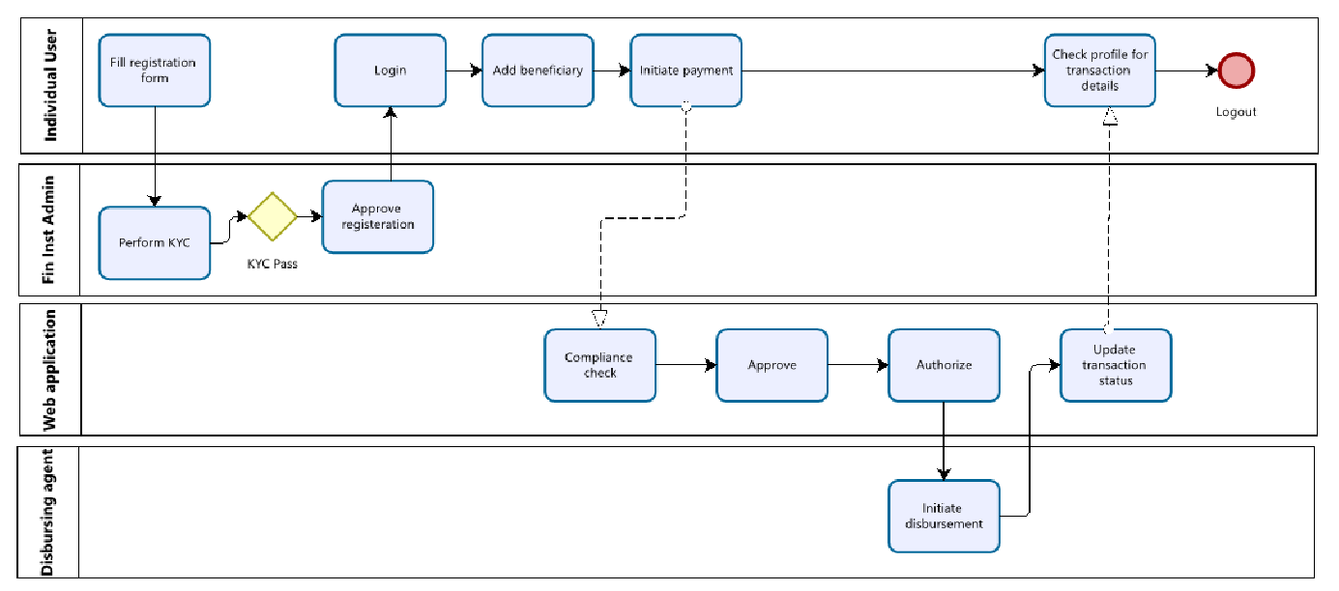

* Company user flow –

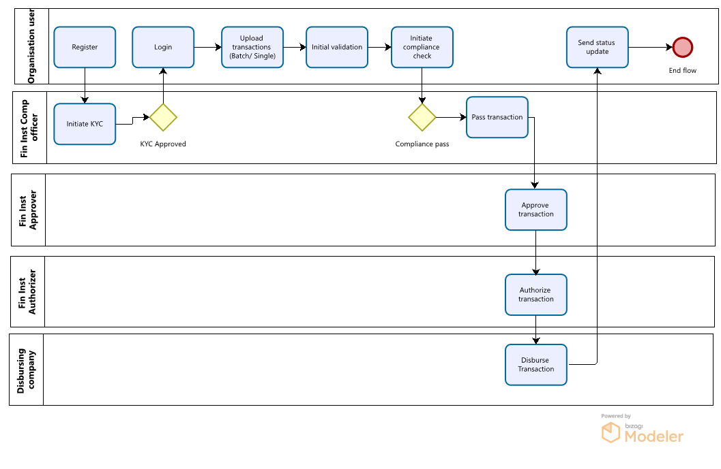

# **Non-Functional Requirements**

* The application must be cross browser compatible (Chrome, Edge, Safari, Firefox)
* The mobile application must be compatible with Android and IOS.
* Each page must load within 2 seconds.
* The system must meet Web Content Accessibility Guidelines WCAG 2.1.
* Application must be available each day of the year, 24 hrs per day
* Unplanned downtime, calculated on a quarterly basis, shall not exceed 2.16 hours, equivalent to an availability of 99.9%
* Planned downtime may be envisaged in order to manage some exceptional changes that require stopping temporarily the platform service.
* The platform shall be able to retrieve payment instruction and status message data not older than seven years, upon request by participants.
* The platform shall be able to retrieve authentication and security data not older than three months, upon request by participants.
* The platform shall keep an audit trail of all the activities performed by the users while making use of the platform service.
* The platform shall be able to process up to an average number of 500 incoming payment instructions per second, with a peak of up to 2,000 incoming payment instructions per second.

# **Security**

Provide multiple level security to prevent any hacking attempts and to ensure the safety of your funds. Following are the Application-Level Security measures:

* End-to-end encryption using SSL
* All Incoming/Outgoing request route through API Gateway
* Any sensitive user data is kept in encrypted format in the database.
* Request Encryption: Request is get encrypted from client side which is then decrypted on server side
* Secured Authentication:
  1. Multi-logged In Stopped by using the same credential.

○ Two Factor Authentication (SMS, Email, Google Authenticator) on login and withdrawal

* JWT (JSON Web Based Token) Encryption
* Private Key Encryption
* OTP for all transactions
* APP level encrypted preference
* Encryption for 3rd party APIs
* Geography-based rules management
* ISO20022 based Messaging format
* Data mirroring and encryption
* True value always kept at each system

● Protection against:

* DDoS
* SQL Injection
* CSS - Cross site scripting
* Self XSS - JavaScript in browser console
* SSRF - Server-side request forgery
* HTTP Parameter Pollution attack
* File Inclusion

# **Third-Party Backend Integration**

|  |  |
| --- | --- |
| **Backend Integration** | * KYC integration * Compliance Screening * FX API integration * API Integration for disbursement *(all API integrations are to be kept open and based on customer needs)* |